

**TECHNICAL UNIVERSITY OF KENYA**

**FACULTY OF APPLIED SCIENCES**

**KINYUA NICHOLAS MUCHIRI**

**SCCJ/01100/2018**

**Signature:**

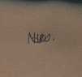

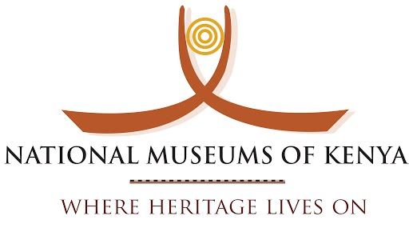

**Place of attachment: NATIONAL MUSEUM OF KENYA**

**Start date: JANUARY 16TH 2023**

**End date: APRIL 6TH 2023**

Contents

**1.0 Executive summary** 3

**1.** **Selection of the establishment** 3

**2.** **Application procedure** 3

**3.** **Frame conditions agreed** 3

**4.** **Job / task definition** 3

**2.0 Introduction of the organization** 4

**1.** **Background of the institution** 4

**2.** **Structure (size, turnover, departments, number of employees)** 5

**3.** **Responsibilities of the organization** 5

**4.** **Functions of the organization** 5

**5.** **Self-concept** 6

1. OUR CORE VALUES 6

2. Professionalism 6

3. Teamwork 6

4. Integrity 6

5. Adaptability 6

6. Environment protection 6

**6.** **About the ICT museum** 6

**7.** **Special regulations** 7

**9.** **Contacts** 7

**3.0** **Description of work station** 7

**1.** **Description of the department (staff, tasks, structural integration within the company, hierarchy levels)** 7

**2.** **Report on the familiarization phase (introduction and mentoring, contact with other employees, etc.)** 8

**3.** **Description of the workstations** 9

**4.** **Task description (handling, cooperation, work results and their presentation, implementation of work results)** 9

**5.** **Description of a typical working day** 9

**6.** **Mentoring situation** 10

**4.0** **Impact of the internship** 10

**4.1 Some of the skills and competencies gained are: -** 10

**4.2 Challenges encountered during the internship** 11

**4.3 Areas of improvements when doing another attachment** 11

**5.0** **Conclusions** 12

**1.0** **Appendices and supplementary material** 13

# 

# **1.0 Executive summary**

## **Selection of the establishment**

I chose the national museums of Kenya over the other two places I had been accepted i.e., Kericho county referral hospital ICT center and County government of Nyeri because of logistics issues. National Museums of Kenya was not far away from where I live and their ICT center had all equipment’s needed for a learning environment.

## **Application procedure**

I applied there physically. I took my attachment form, ID, and all the documents required of me to the human resource department on January 9th. I was called on January 10th and informed that I had been picked and that I should report whenever am ready.

I was required to get a NITA document of placement which took me two days i.e., Wednesday and Thursday so I decided to start my attachment on Monday January 16th.

## **Frame conditions agreed**

The contract was a supervisor (Lorna Mureithi), student contract. There was no pay of any sort. I would only learn and gain experiences from the attachment and that’s it. The working time was 8.00 am to 4.00 pm.

## **Job / task definition**

We were to learn from Lorna as well as other Technical staff the main one being Dan who was the server room technician.

Our tasks included:

Setting up room meetings and conferences e.g., computers and projectors, every morning.

Setting up networks in new buildings i.e., Auditorium

Maintaining already established networks.

Installing new soft-wares for employees all over the institution. The most common being Microsoft office 2019, Windows 10 and 11 operating systems and Kali Linux anti-virus.

Installing new hard-wares and soft-wares in both the old and new server rooms.

# **2.0 Introduction of the organization**

## **Background of the institution**

National Museums of Kenya (NMK) is a state corporation established by an Act of Parliament, the Museums and Heritage Act 2006. NMK is a multi-disciplinary institution whose role is to collect, preserve, study, document and present Kenya’s past and present cultural and natural heritage. This is for the purposes of enhancing knowledge, appreciation, respect and sustainable utilization of these resources for the benefit of Kenya and the world, for now and posterity. NMK’s mutual concern for the welfare of mankind and the conservation of the biological diversity of the East African region and that of the entire planet demands success in such efforts.

## **Structure (size, turnover, departments, number of employees)**

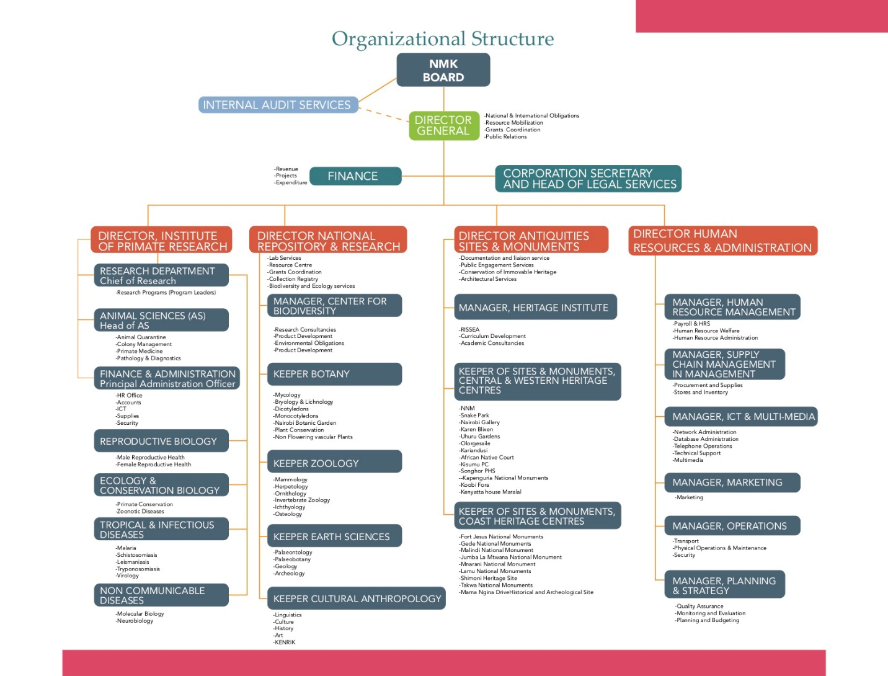

## **Responsibilities of the organization**

1. To serve as a national repository for things of scientific, cultural, technological and human interest
2. To serve as a place where research and dissemination of knowledge in all fields of scientific cultural technological and human interest may be undertaken.
3. To identify, protect, conserve and transmit the cultural and the natural heritage of Kenya.
4. To promote cultural resources in the context of social and economic development
5. To recommend to the government approval for the issuance of excavation, research, exploration and export permits for artifacts and specimens.

## **Functions of the organization**

1. Conservation of Kenya’s protected sites
2. Identification and gazettement of sites
3. Involved in listing of World Heritage Sites
4. Development of museums and sites.
5. Acquisition of title deeds for Museums and sites.
6. Surveying and Mapping of heritage sites.

## **Self-concept**

### OUR CORE VALUES

National Museums of Kenya, shall endeavor to uphold the following key values in the delivery of services to all our clients and stakeholders.

### Professionalism

National Museums of Kenya shall demonstrate expertise, efficiency and competence in the delivery of our duties.

### Teamwork

National Museums of Kenya shall provide quality services to all our stakeholders with the utmost solidarity and mutual cooperation for the benefit of our society.

### Integrity

National Museums of Kenya shall ensure openness in all our dealings and operations Leadership We shall set the pace in shaping the national agenda with respect to the promotion, conservation and management of our cultural and natural diversity.

### Adaptability

National Museums of Kenya shall be creative, innovative and adaptable to the ever emerging trends in heritage management.

### Environment protection

National Museums of Kenya shall at all times work to protect and conserve the environment in line with national and international obligations.

## **About the ICT museum**

The ICT Museum comprises of [galleries](http://museum.mmu.ac.ke/pages/gallery.html) and artifacts ranging from East Africa Postal&philatelic history (Study of stamps), Telephony, Radio&radio transmissions history Computer history, and Film Media history to Mobile phones history. The Museum is open to both internal and external visitors at reasonable fees..

## **Special regulations**

National Museums of Kenya ICT department's self-concept is that of a highly skilled and efficient team that provides excellent support to the institution ICT infrastructure and services. The department prides itself on its ability to troubleshoot and resolve issues quickly, as well as its commitment to providing high-quality guidance and training to county employees.

1. **Measures concerning interns**
2. Obey and observe all industrial/site safety rules and regulations.
3. Not divulge any of the employer’s classified information.
4. Not absent himself/herself during normal working hours without the permission of the employer.
5. Not engage in any other form of employment during working hours.
6. Avail himself/herself for continuous assessment by authorized persons to determine his/her achievement.
7. Maintain the insurance cover for the period of attachment.
8. Cooperate with fellow employees at work.

## **Contacts**

E-mail: publicrelations@museums.or.ke  
Tel: +254721308485

# **3.0** **Description of work station**

## **Description of the department (staff, tasks, structural integration within the company, hierarchy levels)**

In National Museum of Kenya ICT Department, I worked as an attachee in an office consisting of seven employees and four attaches and two volunteers. The department is responsible for providing computer and network installation and maintainance support to all National Museum of Kenya departments. My tasks involved troubleshooting network issues, performing computer software and hardware maintenance, repairing printers, and offering guidance to county employees on ICT matters.

The National Museum of Kenya ICT Department is headed by an ICT Director known as Lawrence Monda https://ke.linkedin.com/in/lawrence-monda-a231428. Who is assisted by an ICT Director, Lucy Waruingi. Under them, there is an ICT Manager, who oversees the daily activities of the department who was my supervisor. The other employees are ICT Officers who perform different technical tasks, such as network administration, software and hardware maintenance, and printer repair.

The first column (communication infrastructure Team):

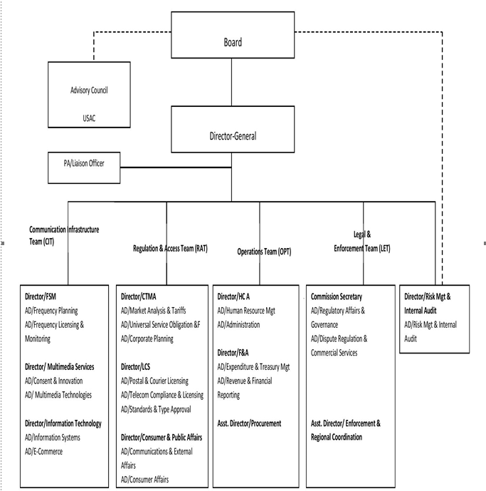

## **Report on the familiarization phase (introduction and mentoring, contact with other employees, etc.)**

On the first week, there is an orientation process in which one is familiralized with the other departments so that when there is a network issue, troubleshooting will be quite easy. Also, one is introduced both theoretically and practically to the topology of the organization and issued with all IP addresses i.e., 172.1.x.x for the static ip addresses and 172.16.x.x for the proxy server for those using dynamic ip addressing.

## **Description of the workstations**

There was a massive procurement of equipments during the first few weeks of the attachment especially for the audotrium which was being modernized. Tt was going through a significant change, especially with the network architecture. It had relied upon the old server room for its internet but now we had to connect it to the new server room and install/replace old installations.

There was no mobility outside the organization. Everything happened inside the Museum.

## **Task description (handling, cooperation, work results and their presentation, implementation of work results)**

Attachees and volunteers worked involved:

1. The major work involved installation of new hardware which were procured earlier in the year. i.e., PCs, Monitors, APCs e.t.c
2. Also the installation of soft-wares in these machines i.e., Microsoft office, Windows 10 and 11 operating systems and Kali Linux anti-virus.
3. Troubleshooting printers, removal of paper jam, replacement of cartridges and installation of printer drivers. This was especially during the printing of bulky tender documents.
4. Checking on the old computers in the store, taking an inventory of their specifications while making recommendations on their upgrade and those that had to be disposed.
5. Replacing of faulty devices such as hard discs, VGA and DVI cables, and faulty power cables. I also clipped faulty Ethernet cables connecting to several computers.
6. Repairing faulty boot sectors using a hard disc running a similar operating system or using bootable CDs and choosing repair option to repair corrupt operating systems.

## **Description of a typical working day**

It would often start with setting up computers and projectors and ensuring there is a network in the conference rooms for the meetings. Later during the day we would go and disassemble them. I would then spend the rest of the day performing my assigned tasks, collaborating with other members of the department, and attending meetings where necessary.

## **Mentoring situation**

We would learn something new each morning after setting up the conference by our supervisor or any other employee for that matter such as cisco packet tracer. We would then do it by ourselves on a real router practically. I was able to interact with majority of the National Museum staff, my fellow attaches, and the public in general at every point. This helped me to develop skills and competencies that have greatly impacted on my thinking and understanding as much as my course is concerned.

# **Impact of the internship**

# **4.1 Some of the skills and competencies gained are: -**

1. Crimping of Ethernet cables both T58A and T58B
2. Learned how to configure a swith and a router for WAN and LAN.
3. Learnt about the skills on how to troubleshoot a problem using the substitution technique, which is very important when solving a problem in Hardware and Networking.
4. Organizational behavior and Communication skills that helped me relate well with everyone within the organization.
5. Managerial skills, discipline together with effective communication for proper management.
6. Cooperation and teamwork abilities which are very critical in every workplace.
7. The training depicts the valuable knowledge that I gained through active participation and inquisitive learning practically prior to class work. I was able to apply principles/techniques theoretically learnt in school to a real-life problem-solving solution.
8. The attachment has given me practical experience in the ICT industry, and I believe it will be instrumental in my future study and career planning. I have gained valuable skills that will help me in my future studies and have a competitive edge in the job market.
9. The tasks assigned to me were challenging and helped me develop new skills, and I was able to work with experienced professionals who provided guidance.
10. This experience has also given me insight into the industry, and I am now better equipped to make informed decisions about my future career. I believe that the skills and knowledge I have gained during the attachment will be beneficial as I work toward my degree and future employment opportunities.
11. Exchanged knowledge with my fellow Interns and also provide basic knowledge and skills to the computer illiterate end users.
12. Acquired knowledge and skills in troubleshooting and configuring PC, Printers, and Photocopiers etc.

## **4.2 Challenges encountered during the internship**

1. Exposure

Sometimes the employees would expect me to be knowledgeable in almost every ICT sector as they didn’t understand that the attachment opportunity was the one to provide me with the exposure.

1. Punctuality

It was really tough from me since I come very far from the attachment place. But once I got used to it I was able to plan ahead well to arrive at the proper time. i.e., before 8.00 am.

## **4.3** **Areas of improvements when doing another attachment**

1. Printer maintenance - The Company had to outsource for external developers since I was unable to develop it.
2. Software development – As a student of computer networks, I realized that I had shallow knowledge in the basics software development required for the general IT Technician.
3. Time management – sometimes I would find myself tripping out of the time schedule.
4. Communication skills – in the company, I got introduced to different audiences and I realized that I have to improve on how to address different audiences.

# **Conclusions**

I offer sincere appreciation to National Museum Of Kenya for offering the internship opportunity. It was a great learning experience, familiarizing myself with the practical applications of ICT and security systems installations as well as gaining an insight in the real world requirements in the security systems business. Furthermore, I gained experience in various aspects that include networking, application installation, troubleshooting, PC maintenance and repairs. Even though the period initially seemed daunting, soon it became manageable. Further, through the attachment I have gained valuable insight, new concepts, and different work scenarios that I have never been exposed to before. Lastly, attachment has offered a wonderful chance to understand usefulness of ICT, its nature and value. Indeed, as I wind up my studies at school, I do trust that I know what the real world requires of me to secure a job after my graduation.

# **Appendices and supplementary material**

Oragnization of the museum:

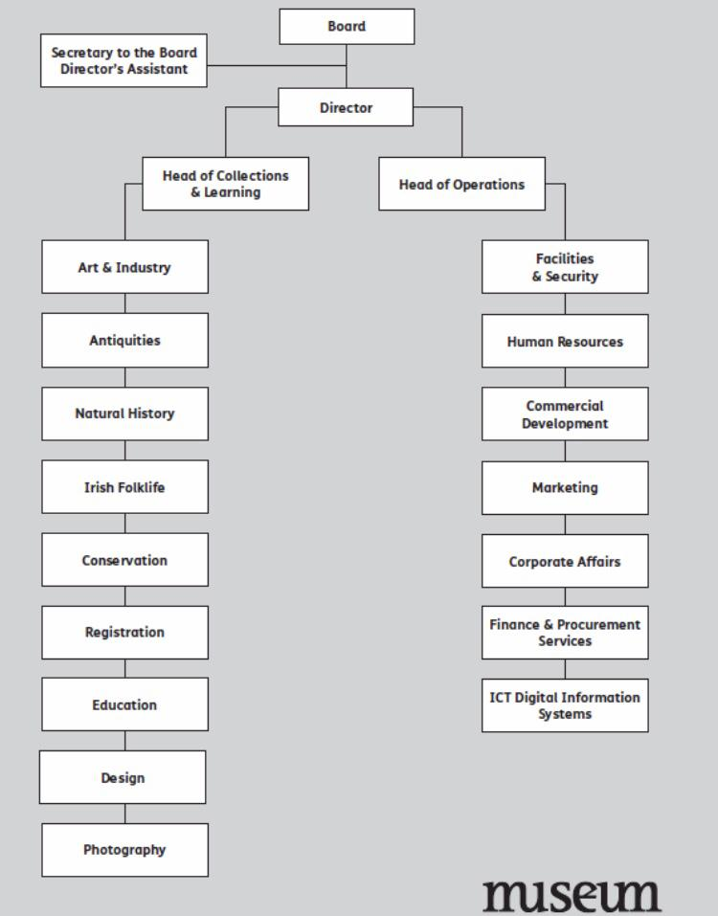

Double click below to find some of the network configurations done:

